# Accessibility Boost: Alt Text

## Question mark icon What?

**Alternative text**, commonly called “Alt Text”, is a hidden description of an image. It is read by screen readers or displayed on the screen when an image fails to load.

## Magnifying glass icon Why?

The **purpose of alternative text** is to describe the important parts of an image to ensure that blind, low-vision, and other learners unable to visually access the image receive an equitable experience and don’t miss key information.

## Icon of a map location Where?

**Alternative text** should be applied to images in documents, presentation slides, course sites, or any other locations that contain visual information.

## Key icon How?

**Alt Text** should be concise and contextual.

### Concise

Describe only the relevant information in the image.

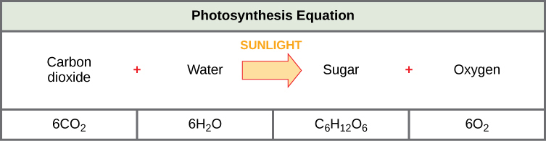

Image from Concepts of Biology - 1st Canadian Edition by Charles Molnar and Jane Gair

A concise description helps highlight the important information in the image: *“The photosynthesis equation shows that six carbon dioxide molecules and six water molecules produce one sugar molecule and one oxygen molecule. The sugar molecule is made of 6 carbons, 12 hydrogens, and 6 oxygens. Sunlight is used as an energy source.”*

### Contextual

Describe the aspects of the image that are important to the specific context in which you’re using it

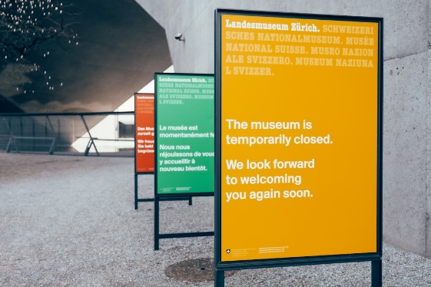In an article about the **underfunding of museums**, the alt text might be *“A sign stating that the museum is temporarily closed”.*

In a presentation about **multi-lingual heritage sites**, the alt text might be *“A row of three signs that read ‘The museum is temporarily closed. We look forward to welcoming you again soon’ in English, French and German.****”***

Photo by Patrick Robert Doyle on Unsplash

### Do

* Include important text that appears in the image in the alt text description
* Use inclusive language in your descriptions (see guide below)
* Mark decorative images as “Decorative” in the alt text menu

Checkbox that reads "Mark as decorative" from Microsoft Word.

### Don’t

* Start descriptions with “Image of…” or “Picture of…”
* Describe images that are purely decorative
* Repeat information that appears elsewhere in the content
* Editorialize or include your own feelings or opinions about the image

## Logo of an ellipse (three periods) More resources

* [**How to add Alt Text to MS Word and PowerPoint**](https://support.microsoft.com/en-us/office/add-alternative-text-to-a-shape-picture-chart-smartart-graphic-or-other-object-44989b2a-903c-4d9a-b742-6a75b451c669) provides steps on how to add alt text to images in different versions of Word and PowerPoint.
* [**Writing Alt Text for Data Visualization**](https://medium.com/nightingale/writing-alt-text-for-data-visualization-2a218ef43f81)provides guidelines on writing alt text for charts, graphs, and other data visualizations
* [**A Guide for Inclusive Language**](https://www.edi.uwo.ca/resources/reports/Inclusive-Language-Guide.pdf) is a comprehensive guide to language for describing people in an inclusive way.